EXP. NO: 4
MATLAB SIMULATION OF SUPERHETERODYNE RECEIVER FOR AM COMMUNICATION SYSTEM WITH FREQUENCY MIXING AND FILTERING
OBJECTIVE:
i) To model and simulate the operation of a superheterodyne receiver for an AM communication system using MATLAB by implementing frequency mixing and intermediate frequency (IF) signal generation.
PROGRAMMING CODE:
clc;
clear;
close all;

% Parameters
Am = 1; % Message amplitude
fm = 500; % Message frequency (Hz)
Ac = 5; % Carrier amplitude
fRF = 10000; % RF carrier frequency (Hz)
fLO = 15000; % Local oscillator frequency (Hz)
fIF = abs(fLO-fRF); % Intermediate frequency (Hz)
mu = 0.5; % Modulation index
fs = 200000; % Sampling frequency
T = 0.02; % Signal duration

% Time vector
t = 0:1/fs:T-1/fs;

% 1. Generate message signal
m = Am*cos(2*pi*fm*t);

% 2. Generate received AM signal
rf = Ac*(1 + mu*cos(2*pi*fm*t)) ...
.* cos(2*pi*fRF*t);

% 3. Generate local oscillator signal
lo = cos(2*pi*fLO*t);

% 4. Frequency mixing
mixed = rf .* lo;

% 5. Design IF bandpass filter
% Pass frequencies around fIF and reject other components
bp = designfilt('bandpassiir', ...
'FilterOrder', 6, ...
'HalfPowerFrequency1', fIF-1500, ...
'HalfPowerFrequency2', fIF+1500, ...
'SampleRate', fs);

% 6. Generate IF signal
if_signal = filtfilt(bp, mixed);

% Frequency spectrum of IF signal
N = length(t);
f = (-N/2:N/2-1)*(fs/N);

RF_FFT = abs(fftshift(fft(rf)))/N;
MIX_FFT = abs(fftshift(fft(mixed)))/N;
IF_FFT = abs(fftshift(fft(if_signal)))/N;

% 7. Plot results
figure('Name','Superheterodyne AM Receiver', ...
'NumberTitle','off');

subplot(3,2,1);
plot(t,m);
title('Original Message Signal');
xlabel('Time (s)');
ylabel('Amplitude');
grid on;

subplot(3,2,2);
plot(t,rf);
title('Received AM Signal (RF)');
xlabel('Time (s)');
ylabel('Amplitude');
grid on;

subplot(3,2,3);
plot(t,lo);
title('Local Oscillator Signal');
xlabel('Time (s)');
ylabel('Amplitude');
grid on;

subplot(3,2,4);
plot(t,mixed);
title('Mixer Output');
xlabel('Time (s)');
ylabel('Amplitude');
grid on;

subplot(3,2,5);
plot(t,if_signal);
title('Filtered Intermediate Frequency Signal');
xlabel('Time (s)');
ylabel('Amplitude');
grid on;

subplot(3,2,6);
plot(f,IF_FFT);
xlim([0 12000]);
title('IF Signal Frequency Spectrum');
xlabel('Frequency (Hz)');
ylabel('Magnitude');
grid on;

% Display calculated frequencies
fprintf('RF Frequency = %d Hz\n',fRF);
fprintf('LO Frequency = %d Hz\n',fLO);
fprintf('Intermediate Frequency = %d Hz\n',fIF);
fprintf('Superheterodyne receiver simulation completed.\n');
OUTPUT:
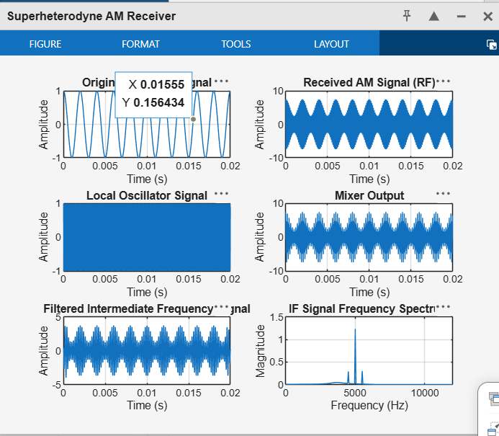

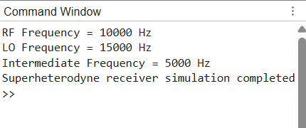
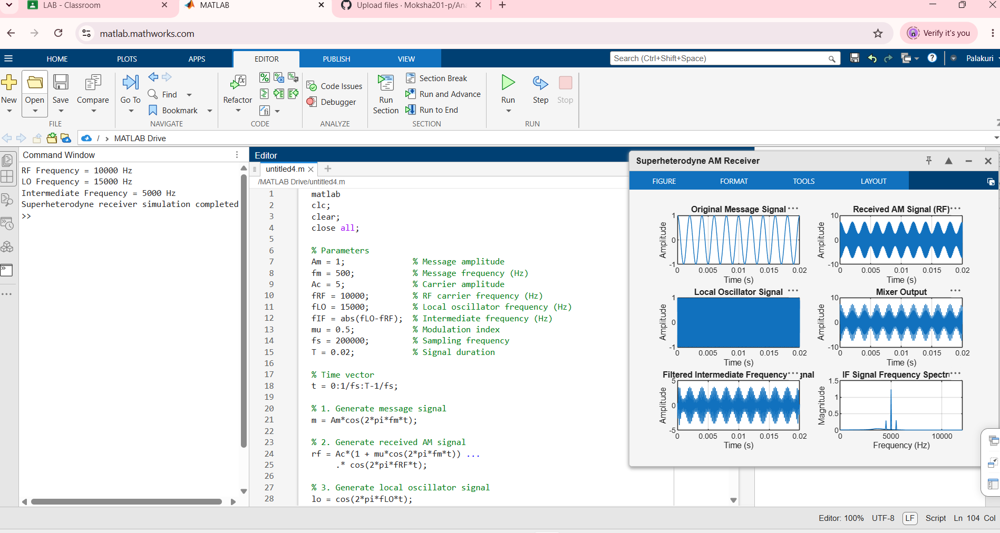

OBJECTIVE 2 :
ii) To recover the original message signal through intermediate frequency filtering and envelope detection, and analyze the waveforms of the message, carrier, AM, IF, and recovered signals.
Programming Code:
clc;
clear;
close all;

% Parameters
Am = 1; % Message amplitude
fm = 500; % Message frequency (Hz)
Ac = 5; % Carrier amplitude
fRF = 10000; % RF carrier frequency (Hz)
fLO = 15000; % Local oscillator frequency (Hz)
fIF = abs(fLO-fRF); % Intermediate frequency (Hz)
mu = 0.5; % Modulation index
fs = 200000; % Sampling frequency
T = 0.02; % Signal duration

% Time vector
t = 0:1/fs:T-1/fs;
N = length(t);

% 1. Generate message signal
m = Am*cos(2*pi*fm*t);

% 2. Generate carrier signal
carrier = Ac*cos(2*pi*fRF*t);

% 3. Generate AM signal
am = Ac*(1 + mu*cos(2*pi*fm*t)) ...
.* cos(2*pi*fRF*t);

% 4. Generate local oscillator signal
lo = cos(2*pi*fLO*t);

% 5. Frequency mixing
mixed = am .* lo;

% 6. Design IF bandpass filter
bp = designfilt('bandpassiir', ...
'FilterOrder', 6, ...
'HalfPowerFrequency1', fIF-1500, ...
'HalfPowerFrequency2', fIF+1500, ...
'SampleRate', fs);

% 7. Extract IF signal
if_signal = filtfilt(bp, mixed);

% 8. Envelope detection
envelope = abs(hilbert(if_signal));

% Remove DC component
recovered = envelope - mean(envelope);

% Normalize recovered message
recovered = recovered / max(abs(recovered));

% 9. Calculate frequency spectrum
f = (-floor(N/2):ceil(N/2)-1)*(fs/N);
IF_FFT = abs(fftshift(fft(if_signal)))/N;

% 10. Plot waveforms
figure('Name','Superheterodyne AM Receiver Analysis', ...
'NumberTitle','off');

subplot(3,2,1);
plot(t,m);
title('Original Message Signal');
xlabel('Time (s)');
ylabel('Amplitude');
grid on;

subplot(3,2,2);
plot(t,carrier);
title('Carrier Signal');
xlabel('Time (s)');
ylabel('Amplitude');
grid on;

subplot(3,2,3);
plot(t,am);
title('AM Modulated Signal');
xlabel('Time (s)');
ylabel('Amplitude');
grid on;

subplot(3,2,4);
plot(t,if_signal);
title('Filtered IF Signal');
xlabel('Time (s)');
ylabel('Amplitude');
grid on;

subplot(3,2,5);
plot(t,m,'b','LineWidth',1.2);
hold on;
plot(t,recovered,'r--','LineWidth',1.2);
title('Original and Recovered Message');
xlabel('Time (s)');
ylabel('Normalized Amplitude');
legend('Original Message','Recovered Message');
grid on;
hold off;

subplot(3,2,6);
plot(f,IF_FFT);
xlim([fIF-2*fm fIF+2*fm]);
title('IF Frequency Spectrum');
xlabel('Frequency (Hz)');
ylabel('Magnitude');
grid on;

% 11. Display results
fprintf('RF Frequency = %d Hz\n',fRF);
fprintf('LO Frequency = %d Hz\n',fLO);
fprintf('IF Frequency = %d Hz\n',fIF);
fprintf('Message Frequency = %d Hz\n',fm);
fprintf('Envelope detection completed successfully.\n');
OUTPUT:
